**Lab 2 Report**

Prepared an application which can update our current location and show the temperature of the current city.

Working

1. Initially we have to agree the terms to share the location information.

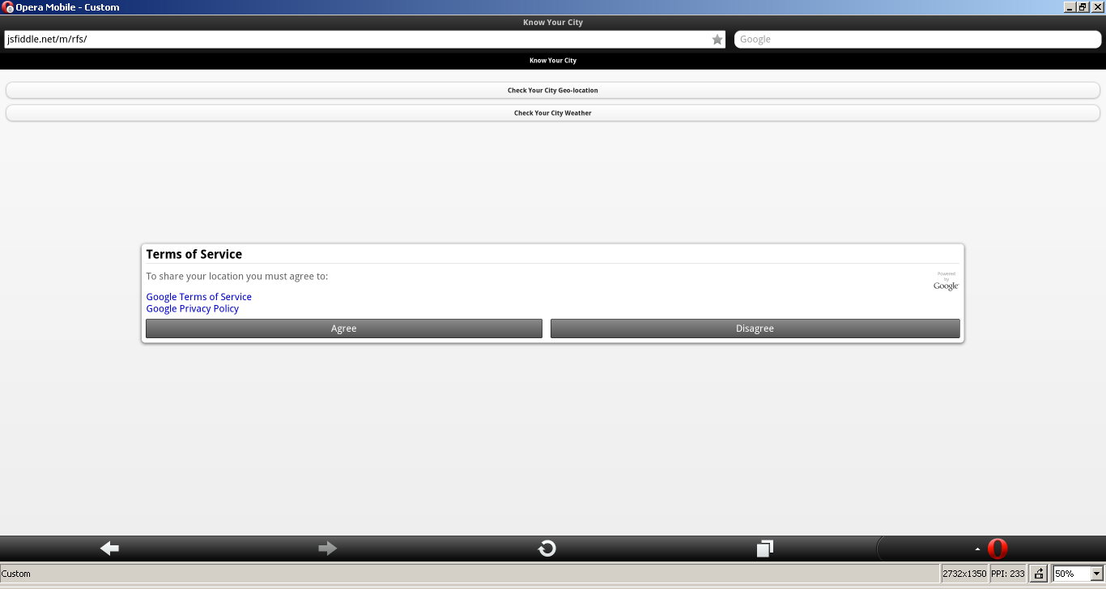

1. Then it will ask for sharing the location.

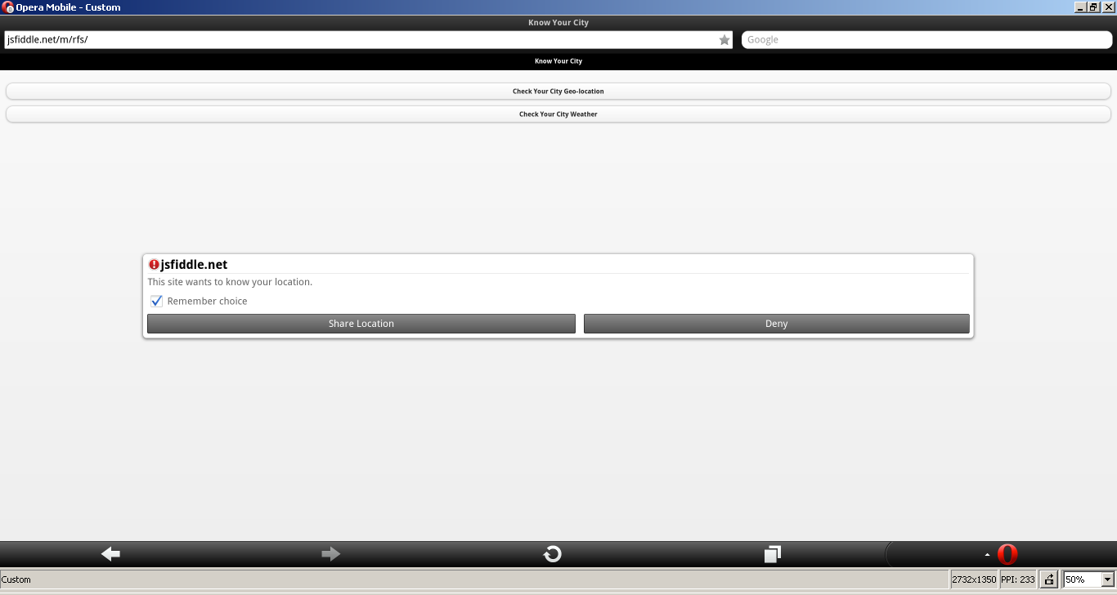

1. Then we access the application.

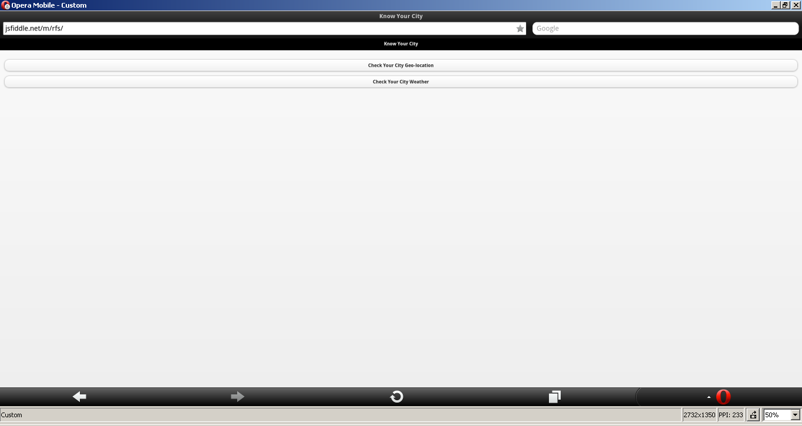

1. After clicking on the geo location tab it will take us to the map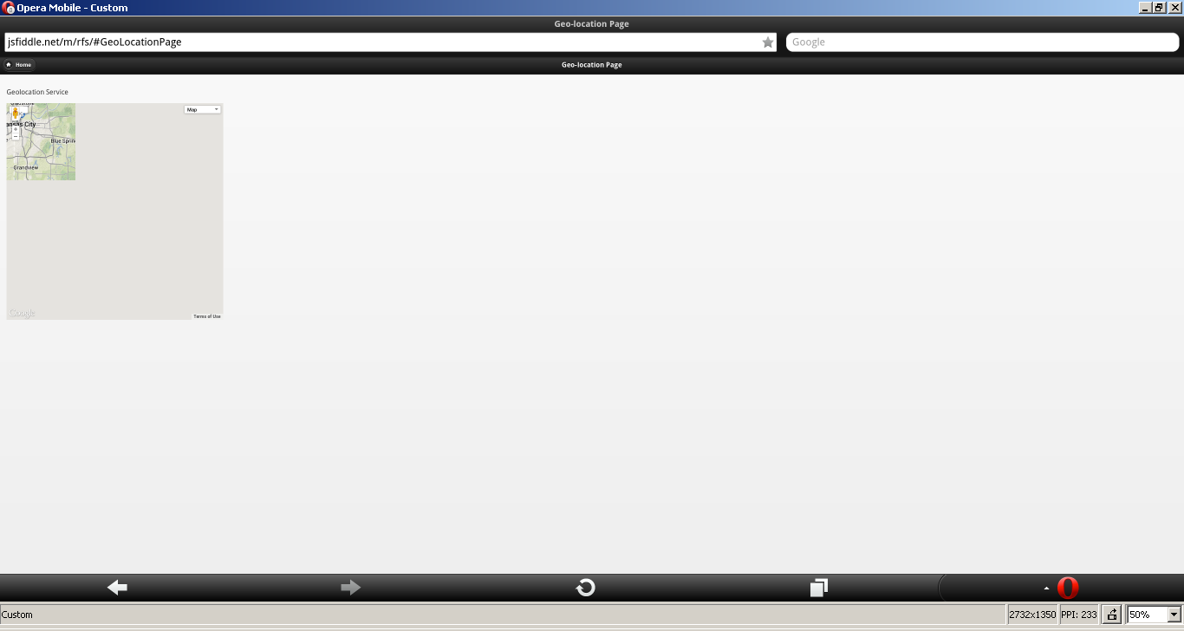
2. We can zoom in and zoom out the map and navigate along with it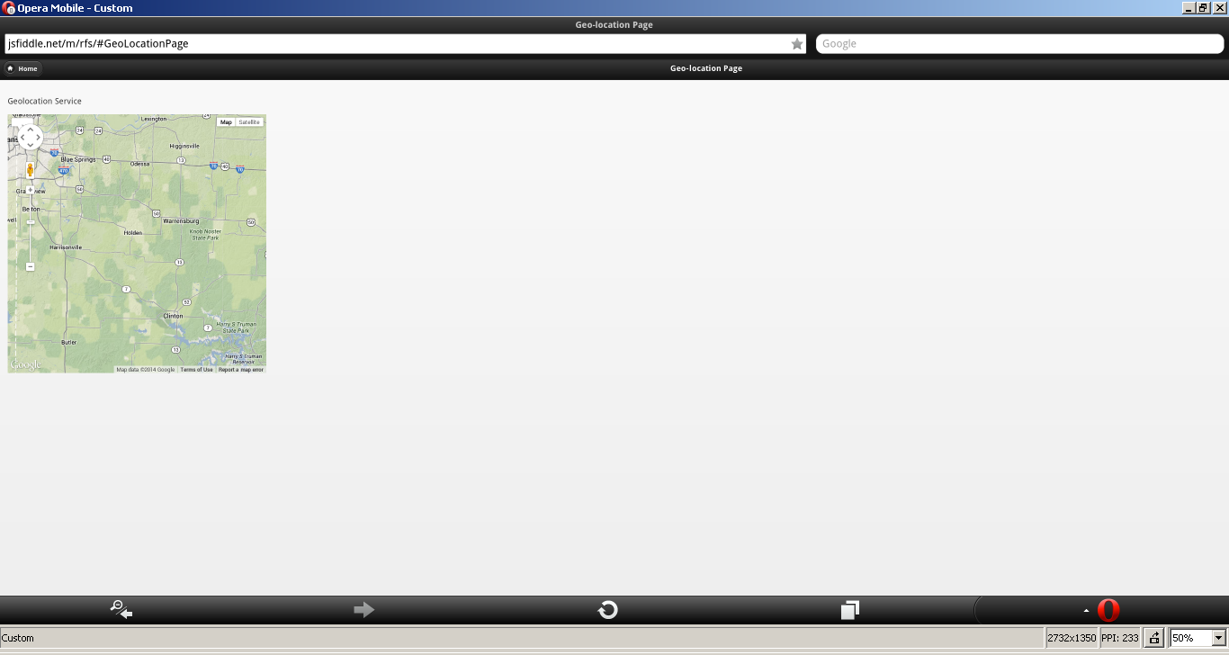
3. By clicking on the home bottom it will take us to the home page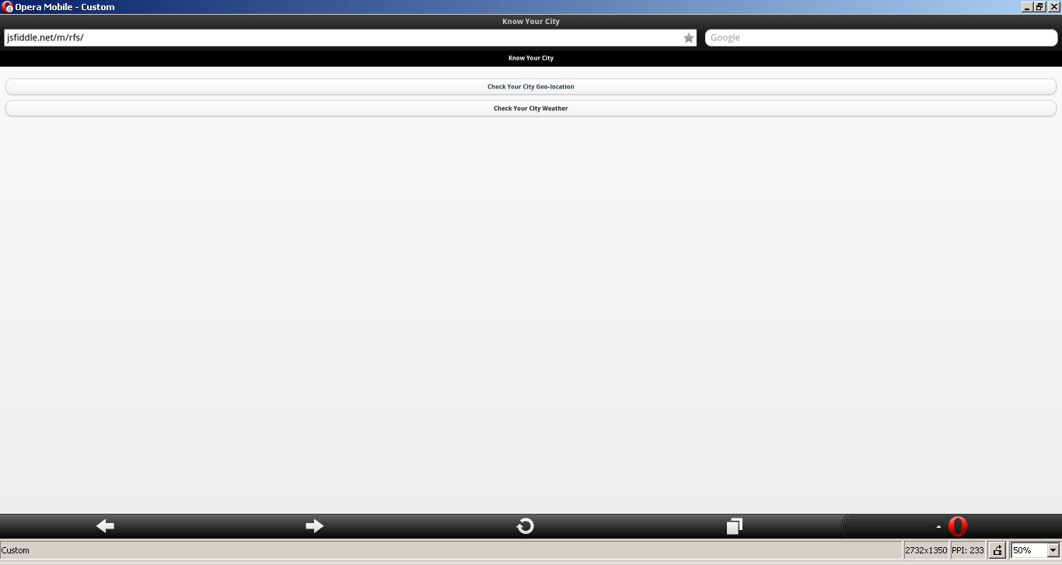
4. By ckicking on to the city weather it will show the weather condition.

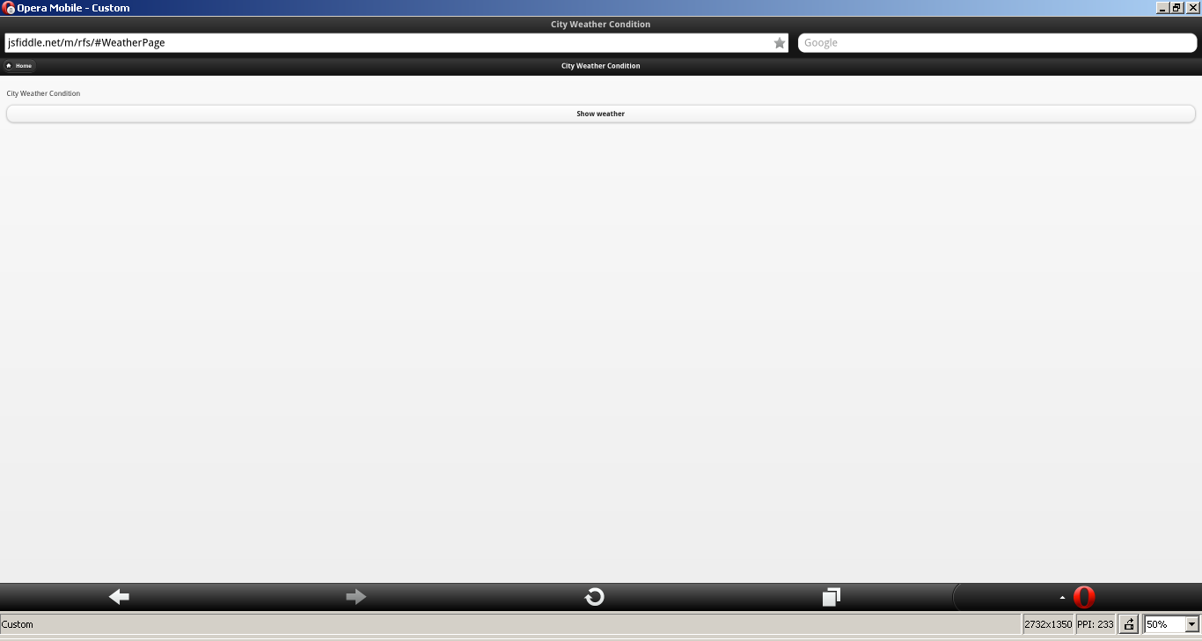

1. It show the weather condition